Quadrilateral
# Source: AI Source: Provided by: [Data Path: Persons Table -> ID Column: 1, Name_En Column: Motasem Essam] -> From: [ChatGPT] on [7/25/2026]
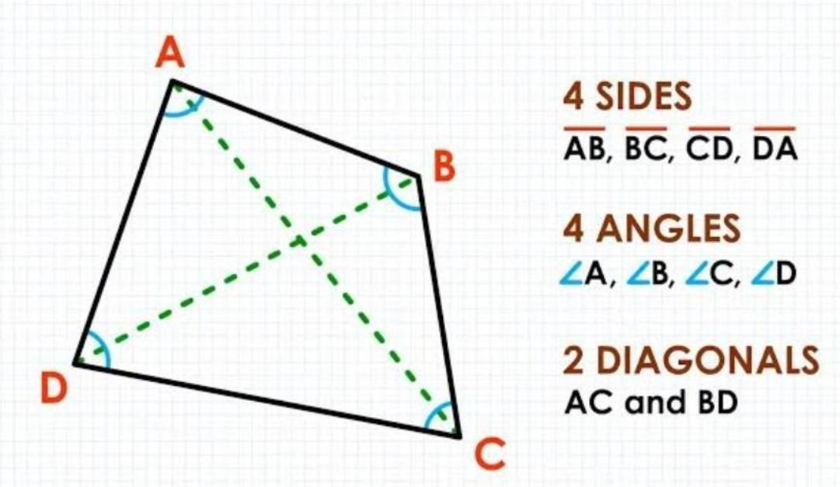
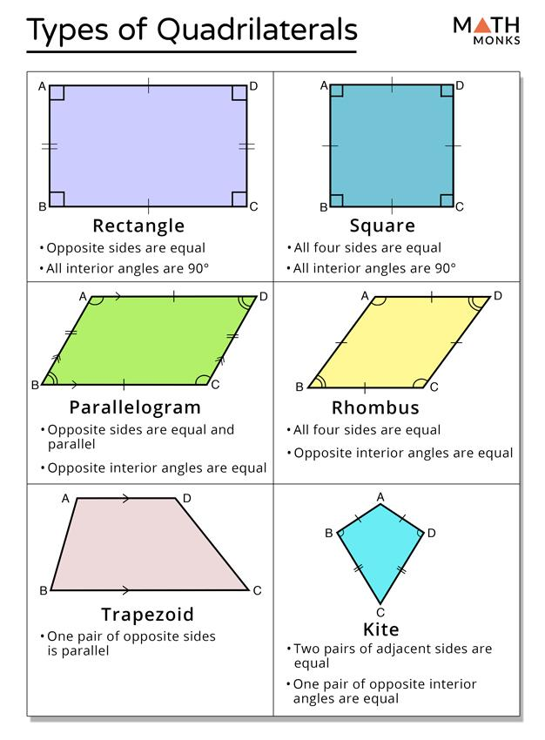
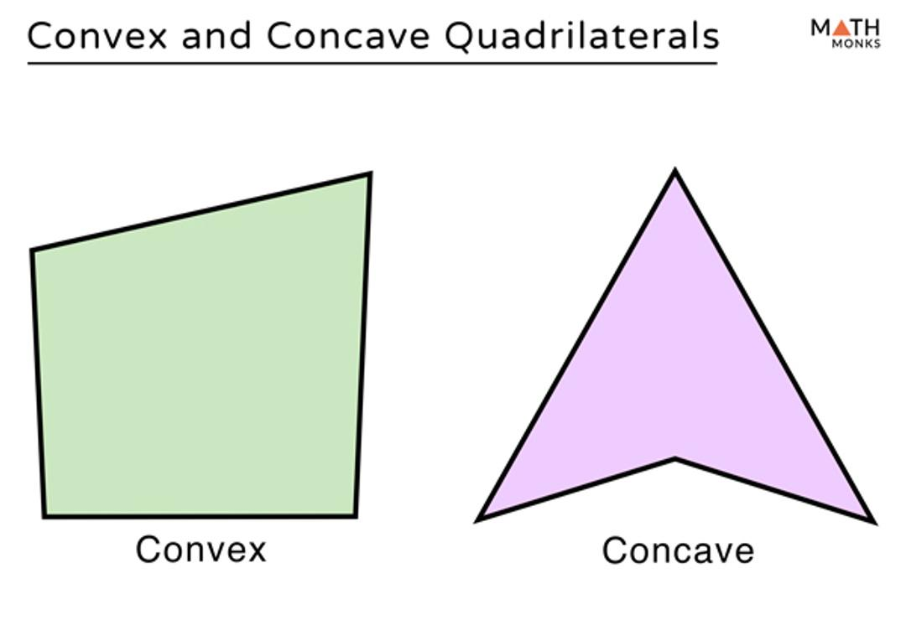
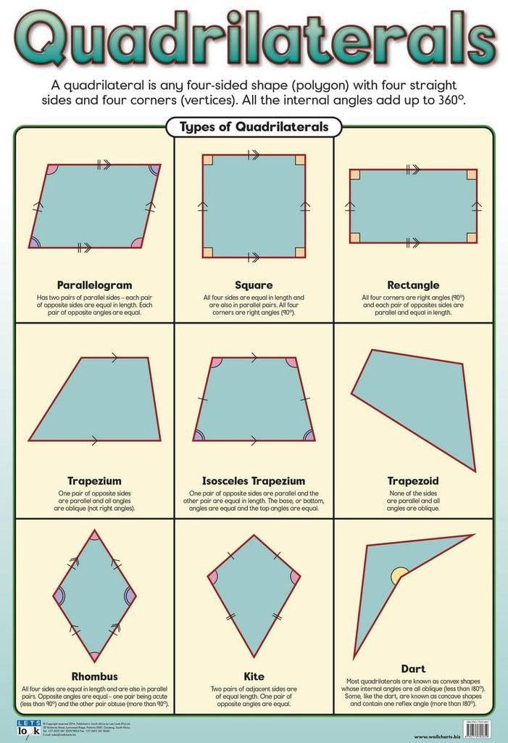
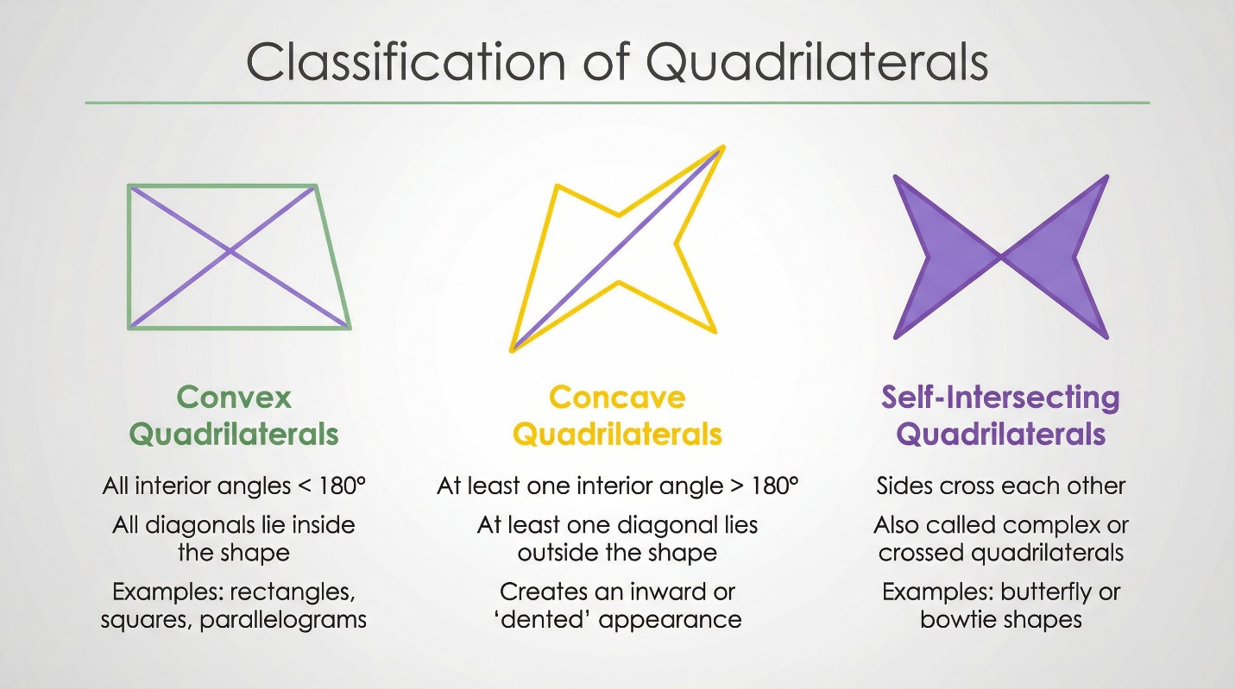

Definition
# Source: AI Source: Provided by: [Data Path: Persons Table -> ID Column: 1, Name_En Column: Motasem Essam] -> From: [ChatGPT] on [7/25/2026]
A quadrilateral is a closed, two-dimensional polygon with four straight sides, four vertices, and four interior angles.
The word quadrilateral comes from the Latin roots meaning “four-sided.”
For quadrilateral $ABCD$:
$$\overset{‾}{AB},\overset{‾}{BC},\overset{‾}{CD},\overset{‾}{DA}$$
are its four sides, and
$$A, B, C, D$$
are its four vertices.

Purpose
# Source: AI Source: Provided by: [Data Path: Persons Table -> ID Column: 1, Name_En Column: Motasem Essam] -> From: [ChatGPT] on [7/25/2026]
Quadrilaterals are used to:
- Study four-sided geometric figures.
- Analyze relationships between sides and angles.
- Calculate perimeter and area.
- Study parallel and perpendicular lines.
- Understand diagonals and symmetry.
- Form the basis of many architectural, engineering, and design shapes.

Fundamental Elements
# Source: AI Source: Provided by: [Data Path: Persons Table -> ID Column: 1, Name_En Column: Motasem Essam] -> From: [ChatGPT] on [7/25/2026]
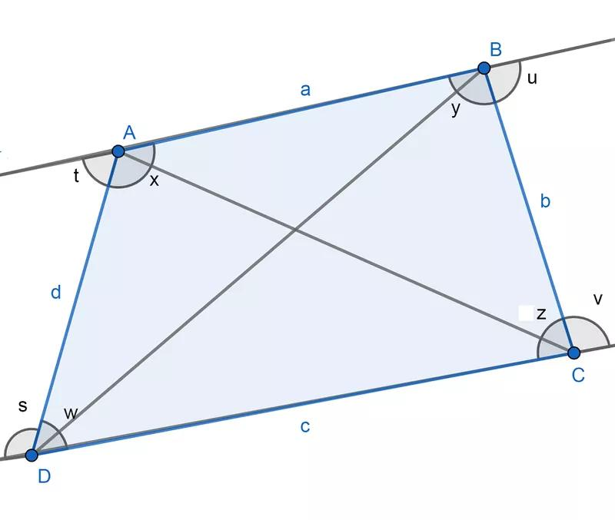
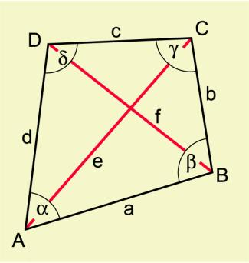
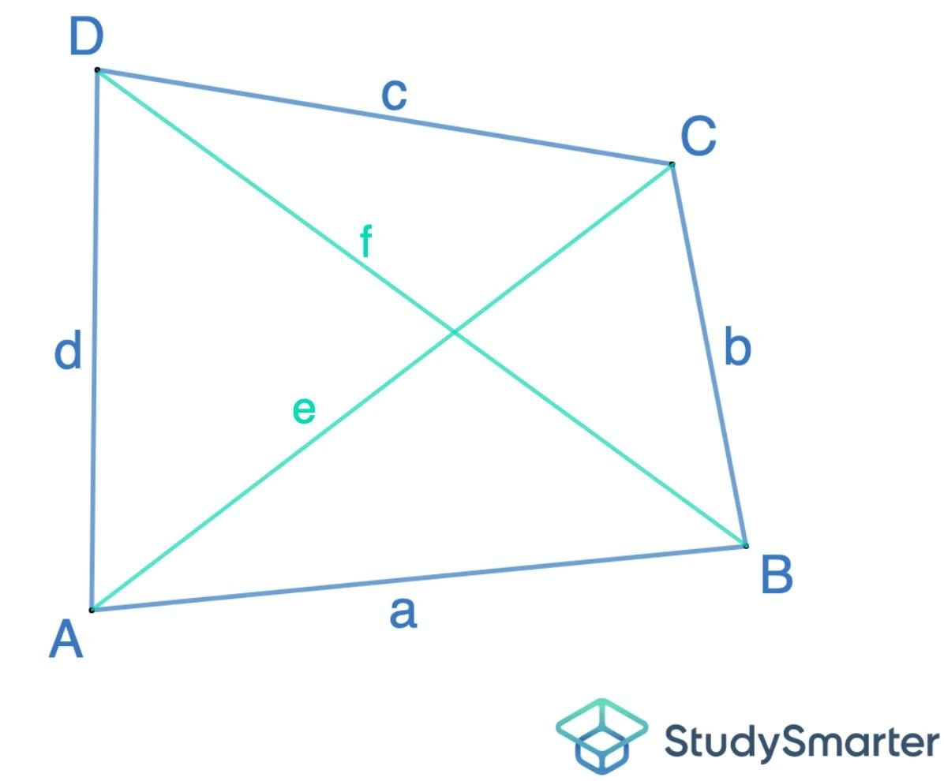
Consider quadrilateral $ABCD$.

1. Sides
# Source: AI Source: Provided by: [Data Path: Persons Table -> ID Column: 1, Name_En Column: Motasem Essam] -> From: [ChatGPT] on [7/25/2026]
The four sides are:
$$\overset{‾}{AB}, \overset{‾}{BC}, \overset{‾}{CD}, \overset{‾}{DA}$$

2. Vertices
# Source: AI Source: Provided by: [Data Path: Persons Table -> ID Column: 1, Name_En Column: Motasem Essam] -> From: [ChatGPT] on [7/25/2026]
The four vertices are:
$$A, B, C, D$$

3. Interior Angles
# Source: AI Source: Provided by: [Data Path: Persons Table -> ID Column: 1, Name_En Column: Motasem Essam] -> From: [ChatGPT] on [7/25/2026]
The four interior angles are:
$$∠A, ∠B, ∠C, ∠D$$

4. Diagonals
# Source: AI Source: Provided by: [Data Path: Persons Table -> ID Column: 1, Name_En Column: Motasem Essam] -> From: [ChatGPT] on [7/25/2026]
A diagonal connects two non-adjacent vertices.
The two diagonals are:
$$\overset{‾}{AC}$$
and
$$\overset{‾}{BD}$$

5. Perimeter
# Source: AI Source: Provided by: [Data Path: Persons Table -> ID Column: 1, Name_En Column: Motasem Essam] -> From: [ChatGPT] on [7/25/2026]
The perimeter is the sum of the four side lengths:
$$\boxed{P=AB+BC+CD+DA}$$

Interior Angle Sum
# Source: AI Source: Provided by: [Data Path: Persons Table -> ID Column: 1, Name_En Column: Motasem Essam] -> From: [ChatGPT] on [7/25/2026]
The sum of the interior angles of every quadrilateral is:
$$\boxed{{360}^{∘}}$$
This follows from dividing the quadrilateral into two triangles.
Each triangle has an angle sum of:
$${180}^{∘}$$
Therefore:
$${180}^{∘}+{180}^{∘}={360}^{∘}$$
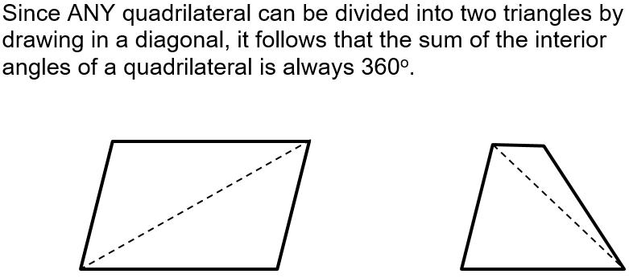
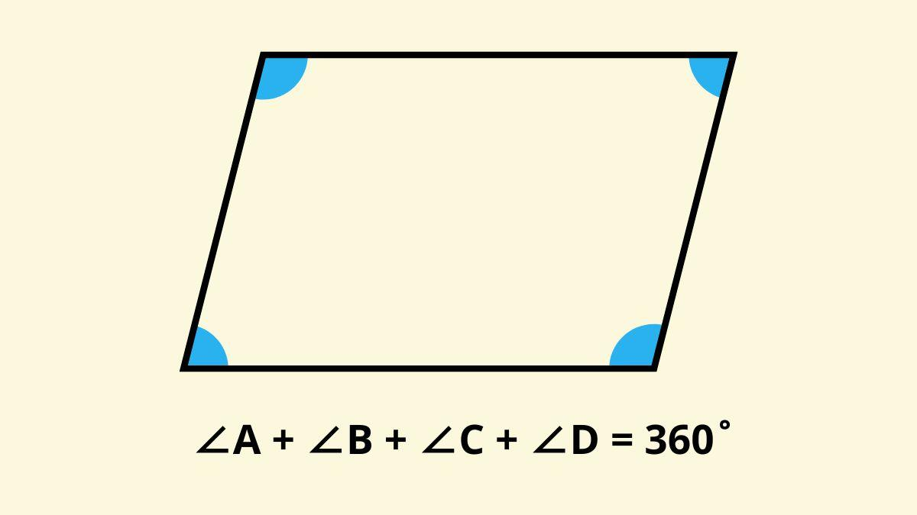
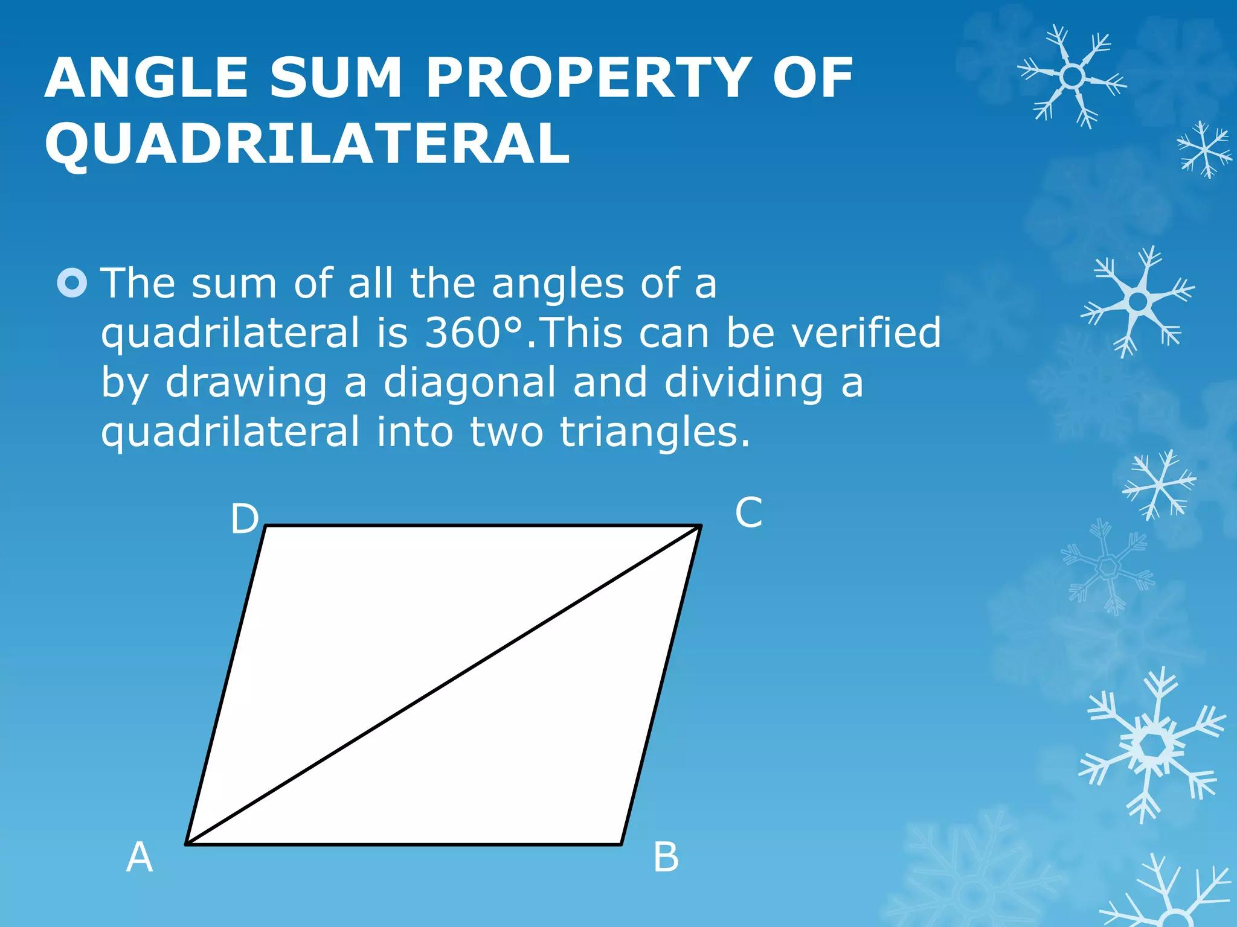
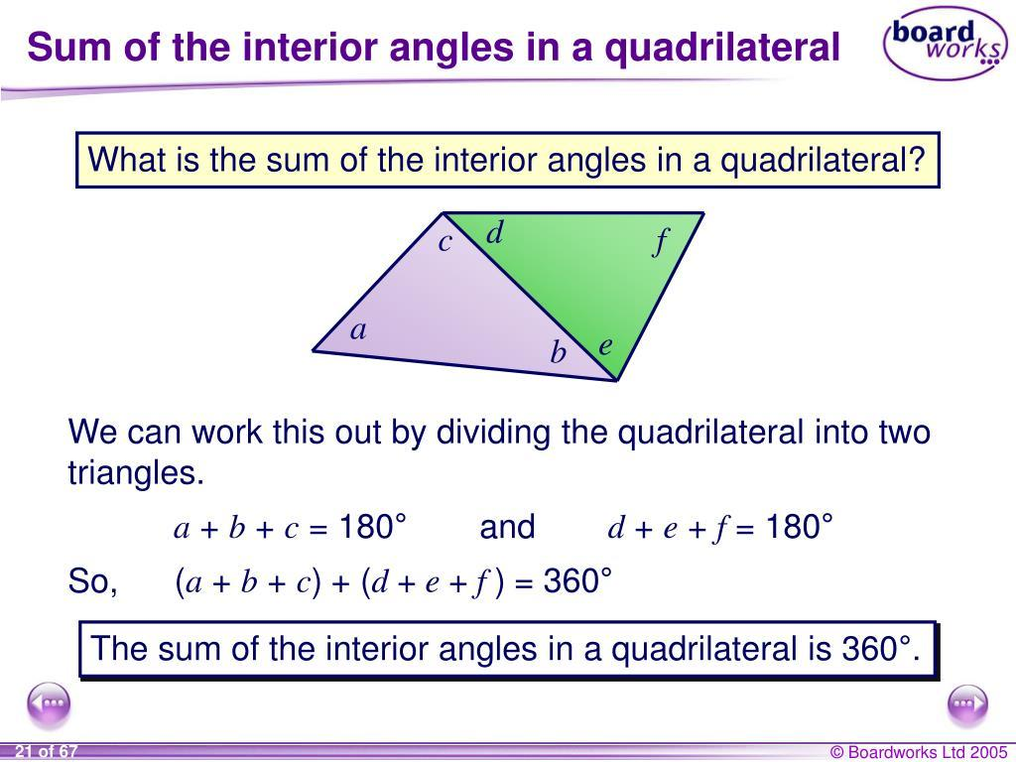
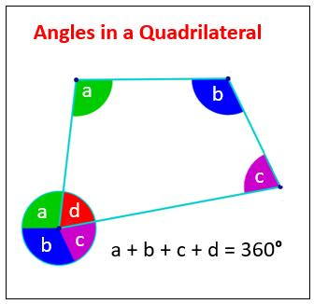
Example
Suppose three angles of a quadrilateral are:
$${80}^{∘}, {100}^{∘}, {70}^{∘}$$
Let the fourth angle be $x$.
$${80}^{∘}+{100}^{∘}+{70}^{∘}+x={360}^{∘} \\ {250}^{∘}+x={360}^{∘} \\ \boxed{x={110}^{∘}}$$

Classification of Quadrilaterals
# Source: AI Source: Provided by: [Data Path: Persons Table -> ID Column: 1, Name_En Column: Motasem Essam] -> From: [ChatGPT] on [7/25/2026]
The major types of quadrilaterals include:
- Parallelogram
- Rectangle
- Rhombus
- Square
- Trapezoid
- Kite
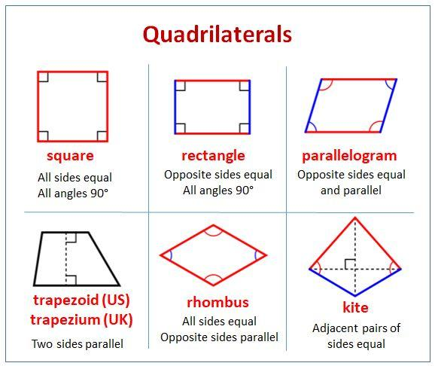
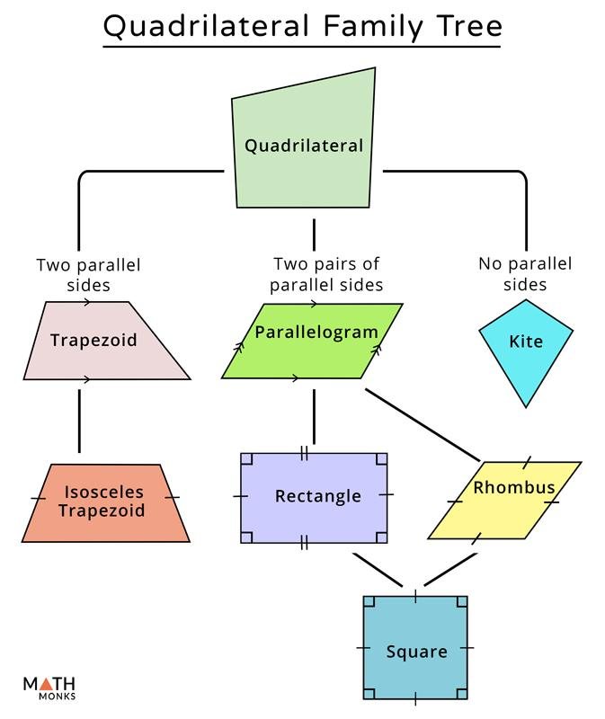
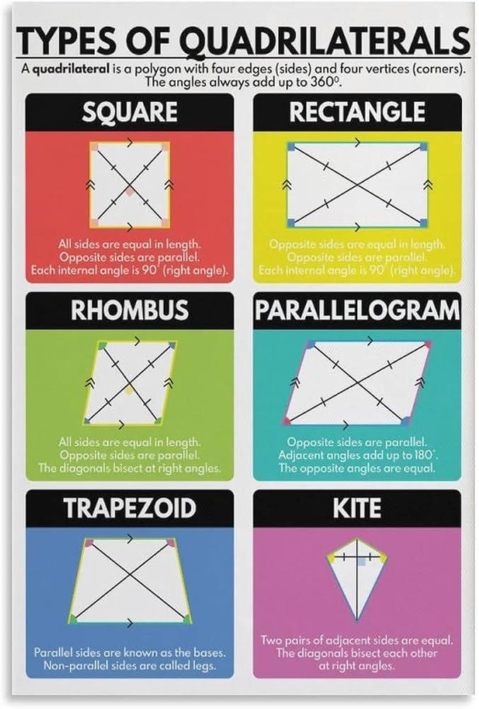
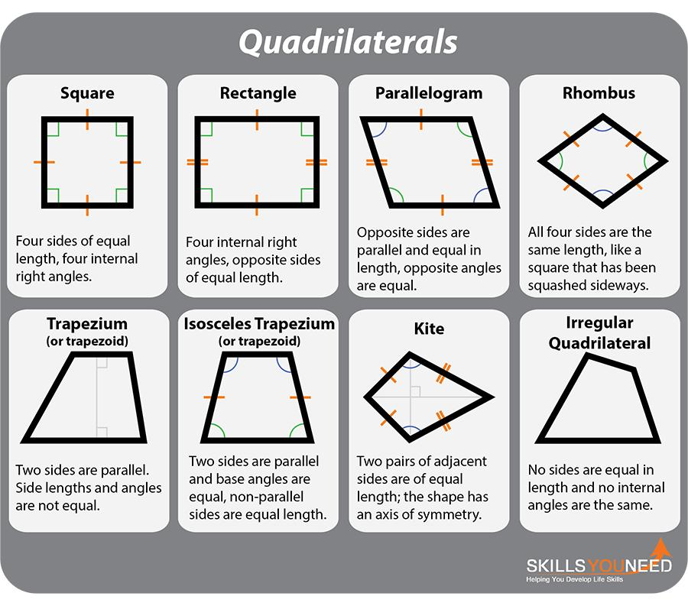

Parallelogram
# Source: AI Source: Provided by: [Data Path: Persons Table -> ID Column: 1, Name_En Column: Motasem Essam] -> From: [ChatGPT] on [7/25/2026]
A parallelogram is a quadrilateral in which both pairs of opposite sides are parallel.
$$AB∥CD$$
and
$$AD∥BC$$
Important properties
- Opposite sides are congruent.
- Opposite angles are congruent.
- Consecutive angles are supplementary.
- Diagonals bisect each other.
If the diagonals intersect at $O$:
$$AO=OC$$
and
$$BO=OD$$

Rectangle
# Source: AI Source: Provided by: [Data Path: Persons Table -> ID Column: 1, Name_En Column: Motasem Essam] -> From: [ChatGPT] on [7/25/2026]
A rectangle is a parallelogram with four right angles.
$$∠A=∠B=∠C=∠D={90}^{∘}$$
Properties
- Opposite sides are equal.
- Opposite sides are parallel.
- All four angles are right angles.
- Diagonals are congruent.
- Diagonals bisect each other.
$$AC=BD$$

Rhombus
# Source: AI Source: Provided by: [Data Path: Persons Table -> ID Column: 1, Name_En Column: Motasem Essam] -> From: [ChatGPT] on [7/25/2026]
A rhombus is a parallelogram with four congruent sides.
$$AB=BC=CD=DA$$
Properties
- All four sides are equal.
- Opposite sides are parallel.
- Opposite angles are equal.
- Diagonals bisect each other.
- Diagonals are perpendicular.
- Diagonals bisect the opposite angles.

Square
# Source: AI Source: Provided by: [Data Path: Persons Table -> ID Column: 1, Name_En Column: Motasem Essam] -> From: [ChatGPT] on [7/25/2026]
A square is a quadrilateral with four equal sides and four right angles.
$$AB=BC=CD=DA$$
and
$$∠A=∠B=∠C=∠D={90}^{∘}$$
A square is simultaneously:
$$\boxed{\text{Rectangle + Rhombus}}$$
Therefore, a square has the important properties of both.
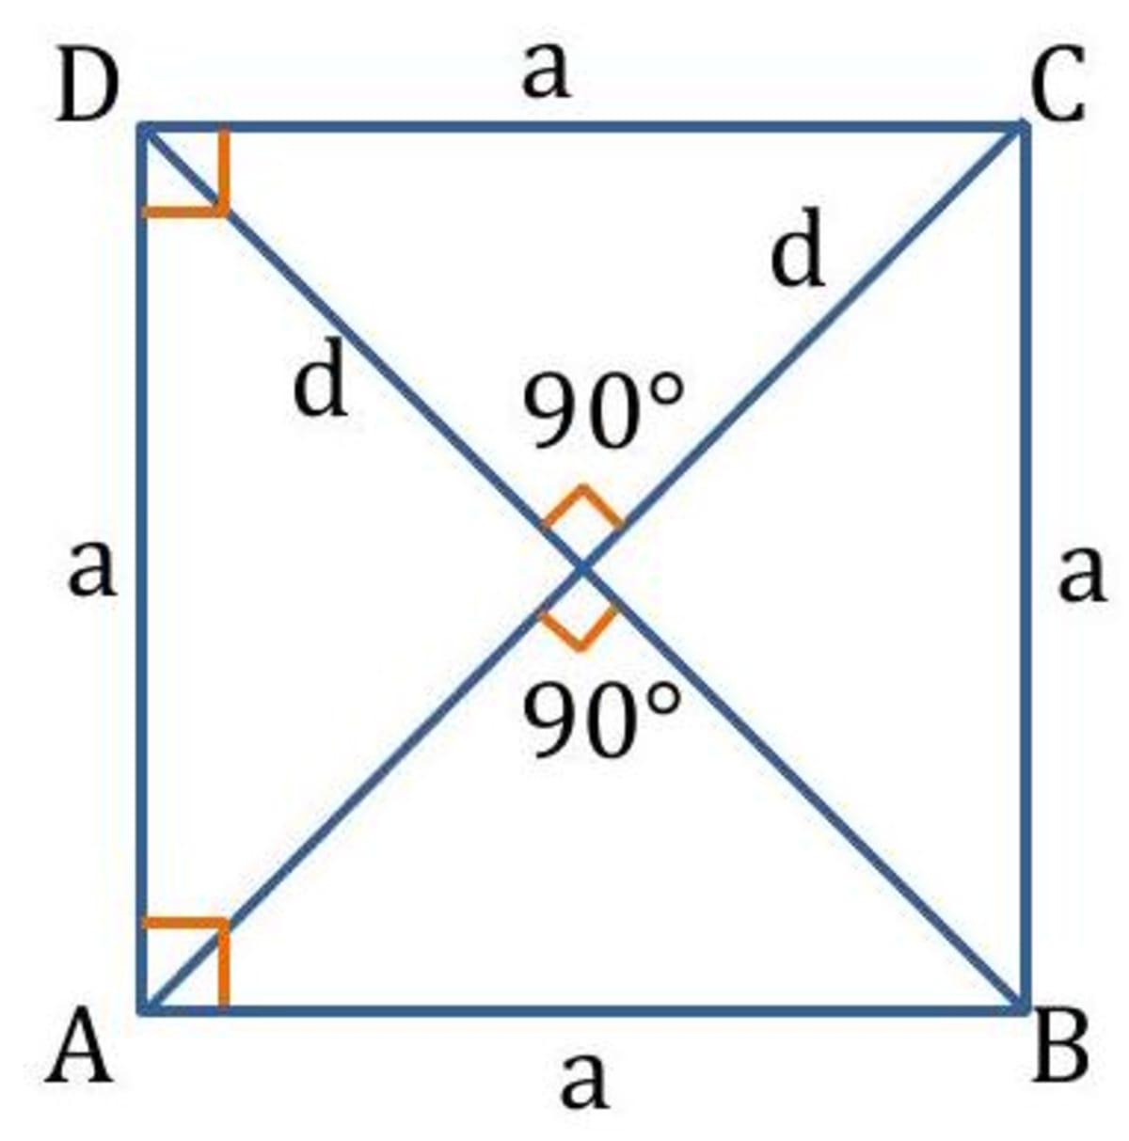
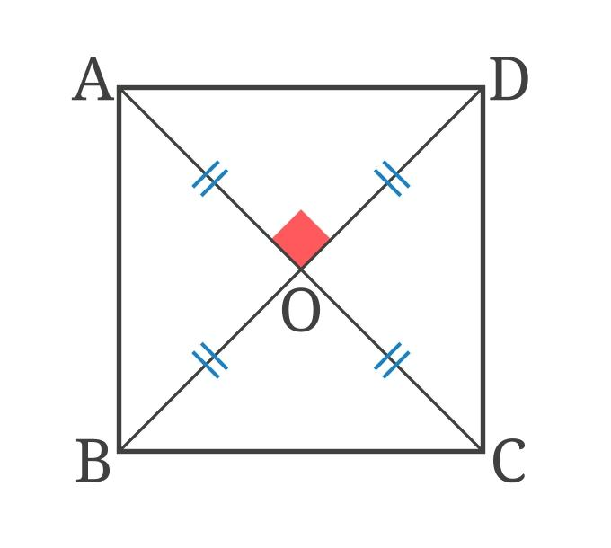
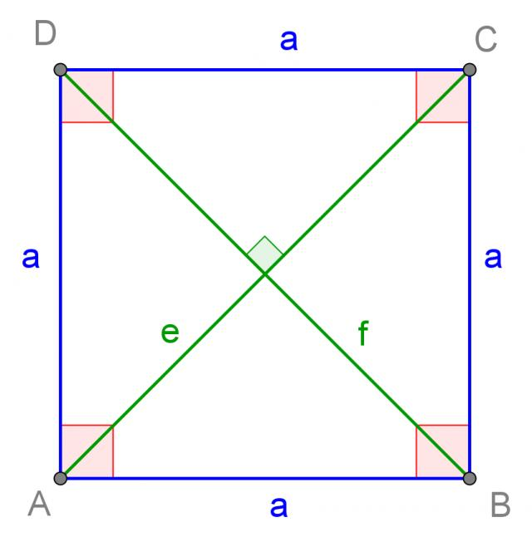
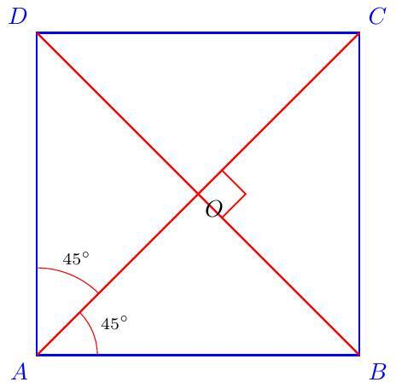
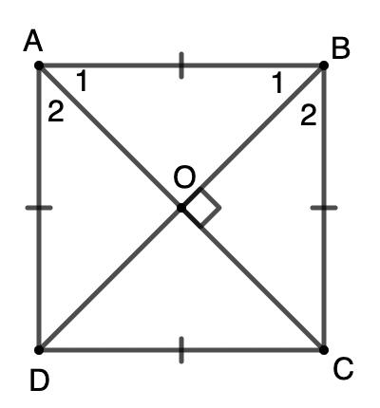

Trapezoid
# Source: AI Source: Provided by: [Data Path: Persons Table -> ID Column: 1, Name_En Column: Motasem Essam] -> From: [ChatGPT] on [7/25/2026]
A trapezoid is a quadrilateral with at least one pair of parallel sides, depending on the convention being used.
The parallel sides are called the bases.
For example:
$$AB∥CD$$
The other sides are called the legs.
Isosceles Trapezoid
An isosceles trapezoid has congruent legs.
It also has:
- Congruent base angles.
- Congruent diagonals.
$$AD=BC$$
and
$$AC=BD$$

Kite
# Source: AI Source: Provided by: [Data Path: Persons Table -> ID Column: 1, Name_En Column: Motasem Essam] -> From: [ChatGPT] on [7/25/2026]
A kite is a quadrilateral with two distinct pairs of adjacent congruent sides.
For example:
$$AB=AD$$
and
$$BC=CD$$
Properties
- Two pairs of adjacent sides are equal.
- One diagonal is perpendicular to the other.
- One diagonal bisects the other.
- One pair of opposite angles is congruent.

Convex and Concave Quadrilaterals

Convex Quadrilateral
# Source: AI Source: Provided by: [Data Path: Persons Table -> ID Column: 1, Name_En Column: Motasem Essam] -> From: [ChatGPT] on [7/25/2026]
A convex quadrilateral has all four interior angles less than:
$${180}^{∘}$$
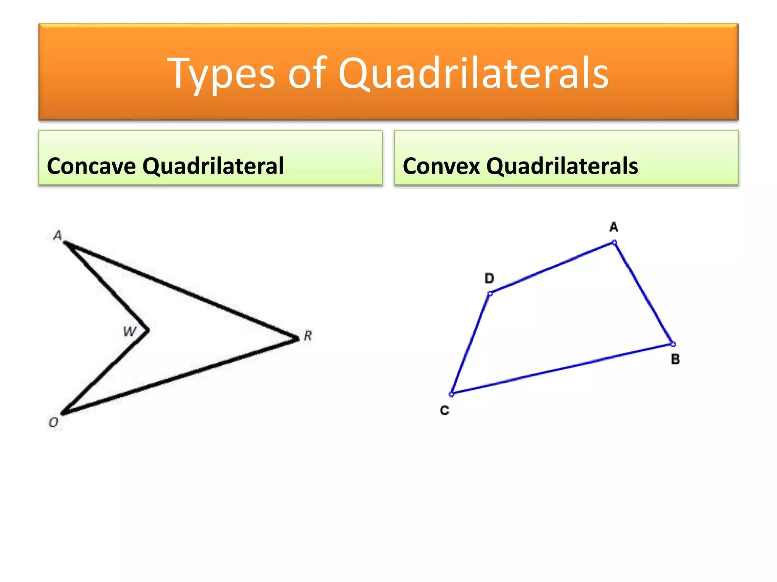
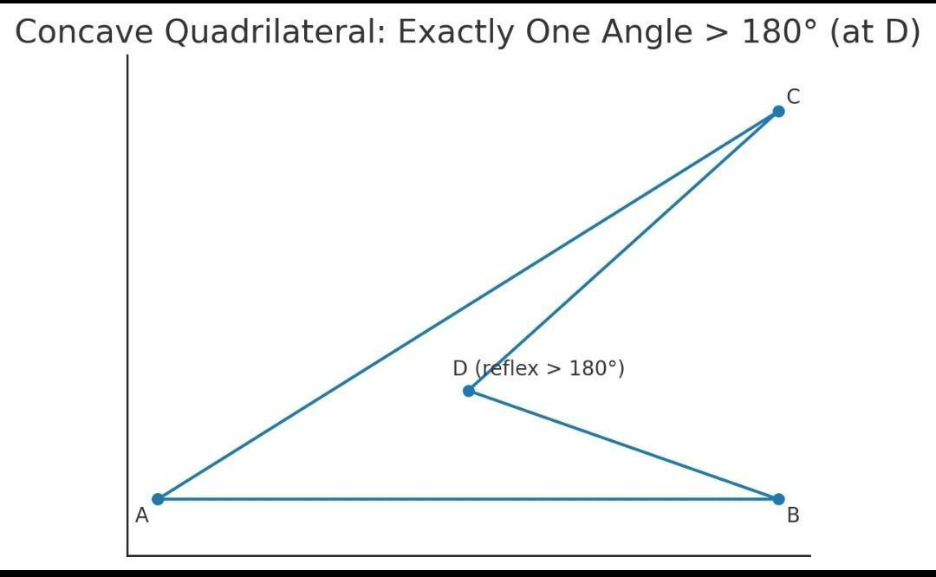
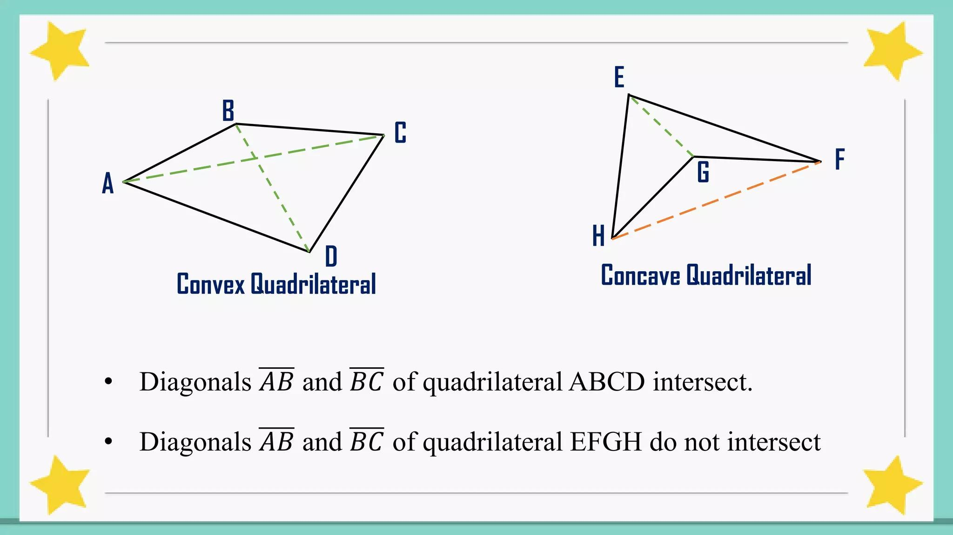
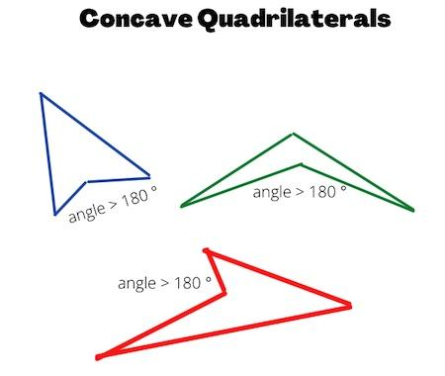

Concave Quadrilateral
# Source: AI Source: Provided by: [Data Path: Persons Table -> ID Column: 1, Name_En Column: Motasem Essam] -> From: [ChatGPT] on [7/25/2026]
A concave quadrilateral has at least one interior angle greater than:
$${180}^{∘}$$
Such an angle is called a reflex angle.

Diagonals
# Source: AI Source: Provided by: [Data Path: Persons Table -> ID Column: 1, Name_En Column: Motasem Essam] -> From: [ChatGPT] on [7/25/2026]
Every quadrilateral has exactly two diagonals.
For $ABCD$:
$$\boxed{\overset{‾}{AC},\overset{‾}{BD}}$$
These diagonals can have different properties depending on the type of quadrilateral.
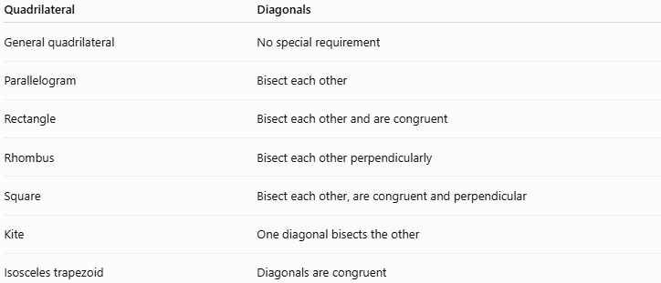
Quadrilateral | Diagonals
General quadrilateral | No special requirement
Parallelogram | Bisect each other
Rectangle | Bisect each other and are congruent
Rhombus | Bisect each other perpendicularly
Square | Bisect each other, are congruent and perpendicular
Kite | One diagonal bisects the other
Isosceles trapezoid | Diagonals are congruent

Area Formulas
# Source: AI Source: Provided by: [Data Path: Persons Table -> ID Column: 1, Name_En Column: Motasem Essam] -> From: [ChatGPT] on [7/25/2026]
The area formula depends on the type of quadrilateral.
Rectangle
$$\boxed{A=lw}$$
where $l$is length and $w$is width.
Square
$$\boxed{A=s^{2}}$$
where $s$is the side length.
Parallelogram
$$\boxed{A=bh}$$
where $b$is the base and $h$is the perpendicular height.
Trapezoid
$$\boxed{A=\frac{1}{2}\left(b_{1}+b_{2}\right)h}$$
where $b_{1}$and $b_{2}$are the parallel bases.
Rhombus
Using its diagonals:
$$\boxed{A=\frac{1}{2}d_{1}d_{2}}$$

Examples

Example 1: Identify a Quadrilateral
# Source: AI Source: Provided by: [Data Path: Persons Table -> ID Column: 1, Name_En Column: Motasem Essam] -> From: [ChatGPT] on [7/25/2026]
A closed figure has four straight sides.
Therefore, it is a:
$$\boxed{\text{Quadrilateral}}$$

Example 2: Find a Missing Angle
# Source: AI Source: Provided by: [Data Path: Persons Table -> ID Column: 1, Name_En Column: Motasem Essam] -> From: [ChatGPT] on [7/25/2026]
A quadrilateral has angles:
$${90}^{∘}, {80}^{∘}, {110}^{∘}, x$$
Since the angle sum is ${360}^{∘}$:
$${90}^{∘}+{80}^{∘}+{110}^{∘}+x={360}^{∘} \\ {280}^{∘}+x={360}^{∘} \\ \boxed{x={80}^{∘}}$$

Example 3: Find the Perimeter
# Source: AI Source: Provided by: [Data Path: Persons Table -> ID Column: 1, Name_En Column: Motasem Essam] -> From: [ChatGPT] on [7/25/2026]
A quadrilateral has side lengths:
$$6, 8, 10, 12$$
Then:
$$P=6+8+10+12 \\ \boxed{P=36}$$

Example 4: Rectangle Area
# Source: AI Source: Provided by: [Data Path: Persons Table -> ID Column: 1, Name_En Column: Motasem Essam] -> From: [ChatGPT] on [7/25/2026]
A rectangle has length $12$cm and width $5$cm.
$$A=lw \\ A=12\left(5\right) \\ \boxed{A=60{\text{ cm}}^{2}}$$

Example 5: Square Area
# Source: AI Source: Provided by: [Data Path: Persons Table -> ID Column: 1, Name_En Column: Motasem Essam] -> From: [ChatGPT] on [7/25/2026]
A square has side length $7$cm.
$$A=s^{2} \\ A=7^{2} \\ \boxed{A=49{\text{ cm}}^{2}}$$

Relationships Among Quadrilaterals
# Source: AI Source: Provided by: [Data Path: Persons Table -> ID Column: 1, Name_En Column: Motasem Essam] -> From: [ChatGPT] on [7/25/2026]
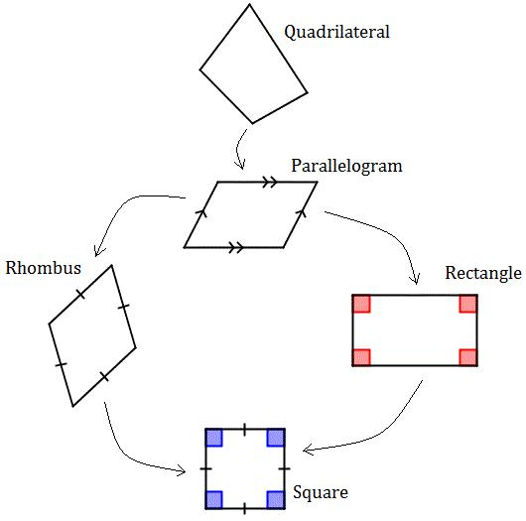
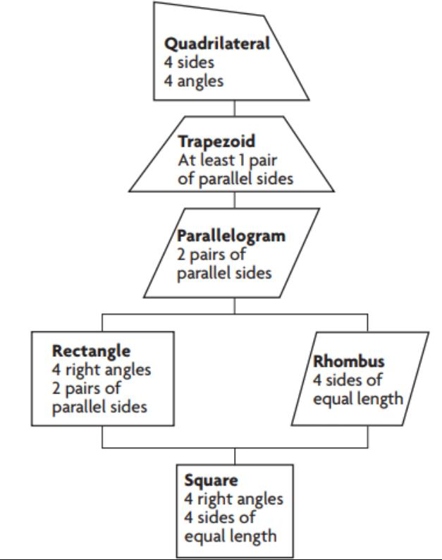
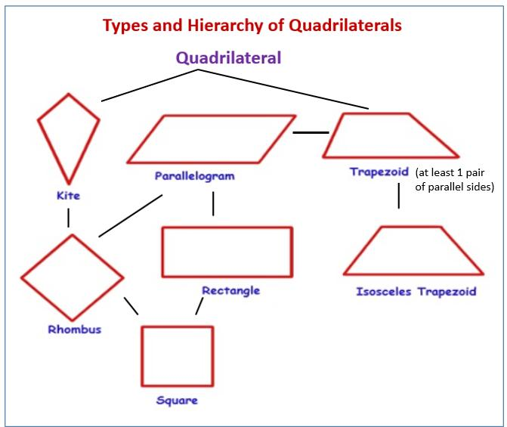
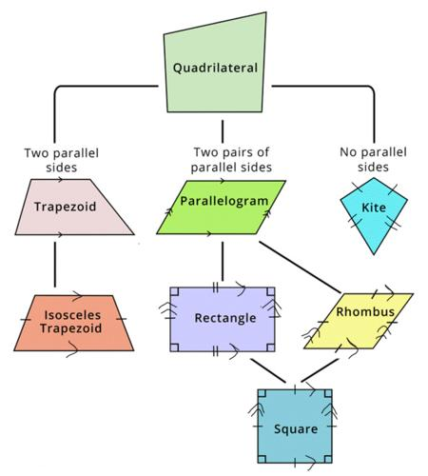
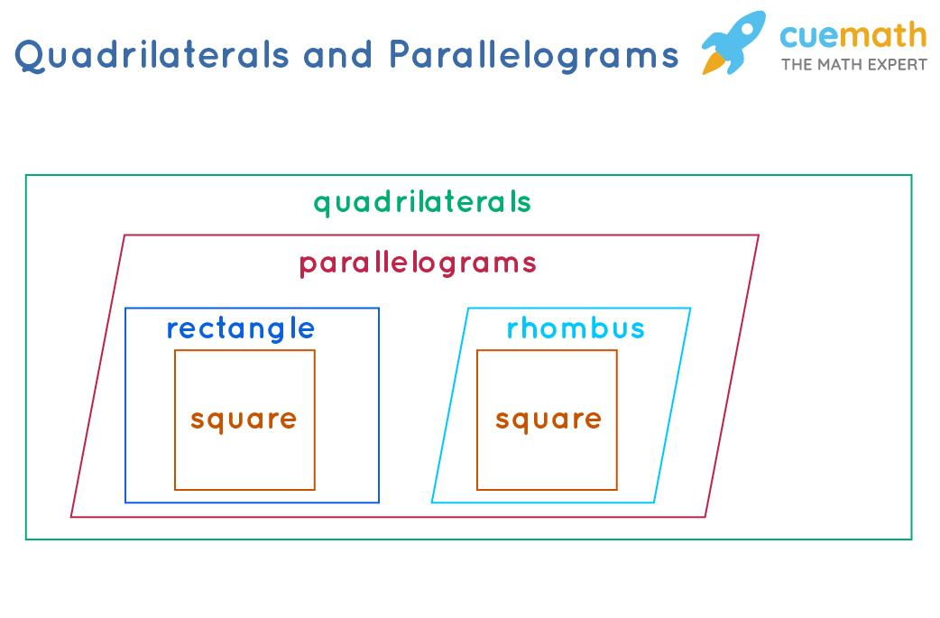
The relationships can be represented as:
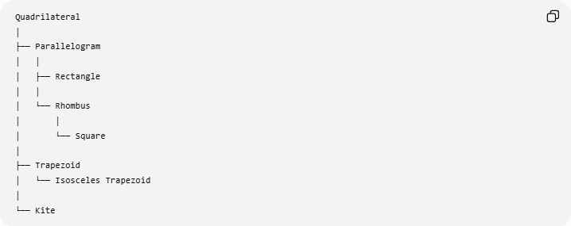
Quadrilateral
│
├── Parallelogram
│ │
│ ├── Rectangle
│ │
│ └── Rhombus
│ │
│ └── Square
│
├── Trapezoid
│ └── Isosceles Trapezoid
│
└── Kite
An important relationship is:
$$\boxed{\text{Square is both a rectangle and a rhombus}}$$
But:
- Not every rectangle is a square.
- Not every rhombus is a square.
- Not every parallelogram is a rectangle.
- Not every parallelogram is a rhombus.

Comparison of Major Quadrilaterals
# Source: AI Source: Provided by: [Data Path: Persons Table -> ID Column: 1, Name_En Column: Motasem Essam] -> From: [ChatGPT] on [7/25/2026]
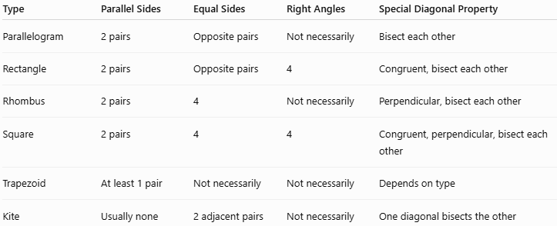
Type | Parallel Sides | Equal Sides | Right Angles | Special Diagonal Property
Parallelogram | 2 pairs | Opposite pairs | Not necessarily | Bisect each other
Rectangle | 2 pairs | Opposite pairs | 4 | Congruent, bisect each other
Rhombus | 2 pairs | 4 | Not necessarily | Perpendicular, bisect each other
Square | 2 pairs | 4 | 4 | Congruent, perpendicular, bisect each other
Trapezoid | At least 1 pair | Not necessarily | Not necessarily | Depends on type
Kite | Usually none | 2 adjacent pairs | Not necessarily | One diagonal bisects the other

Real-World Applications
# Source: AI Source: Provided by: [Data Path: Persons Table -> ID Column: 1, Name_En Column: Motasem Essam] -> From: [ChatGPT] on [7/25/2026]
Quadrilaterals are extremely common in:
- Building walls and floors.
- Doors and windows.
- Tables and screens.
- Books and paper.
- Road signs.
- Tiles and floor patterns.
- Engineering components.
- Computer and phone displays.
- Maps and land boundaries.
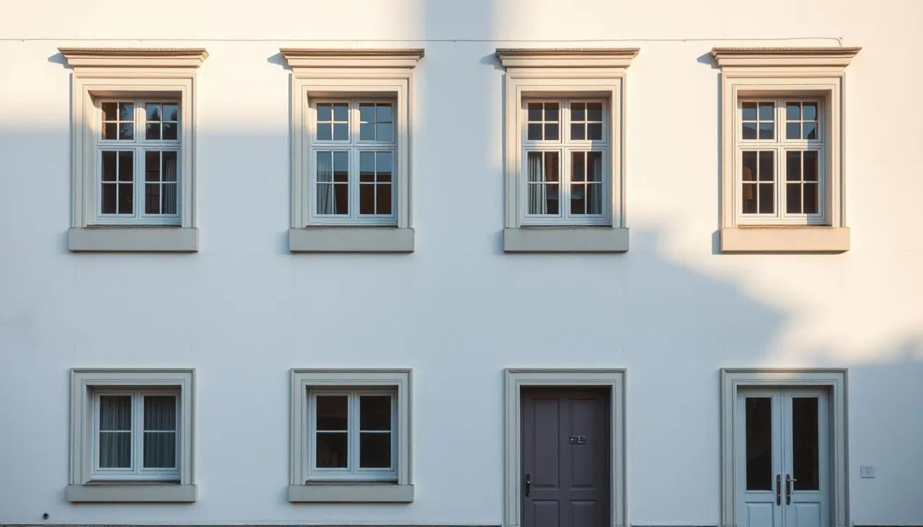
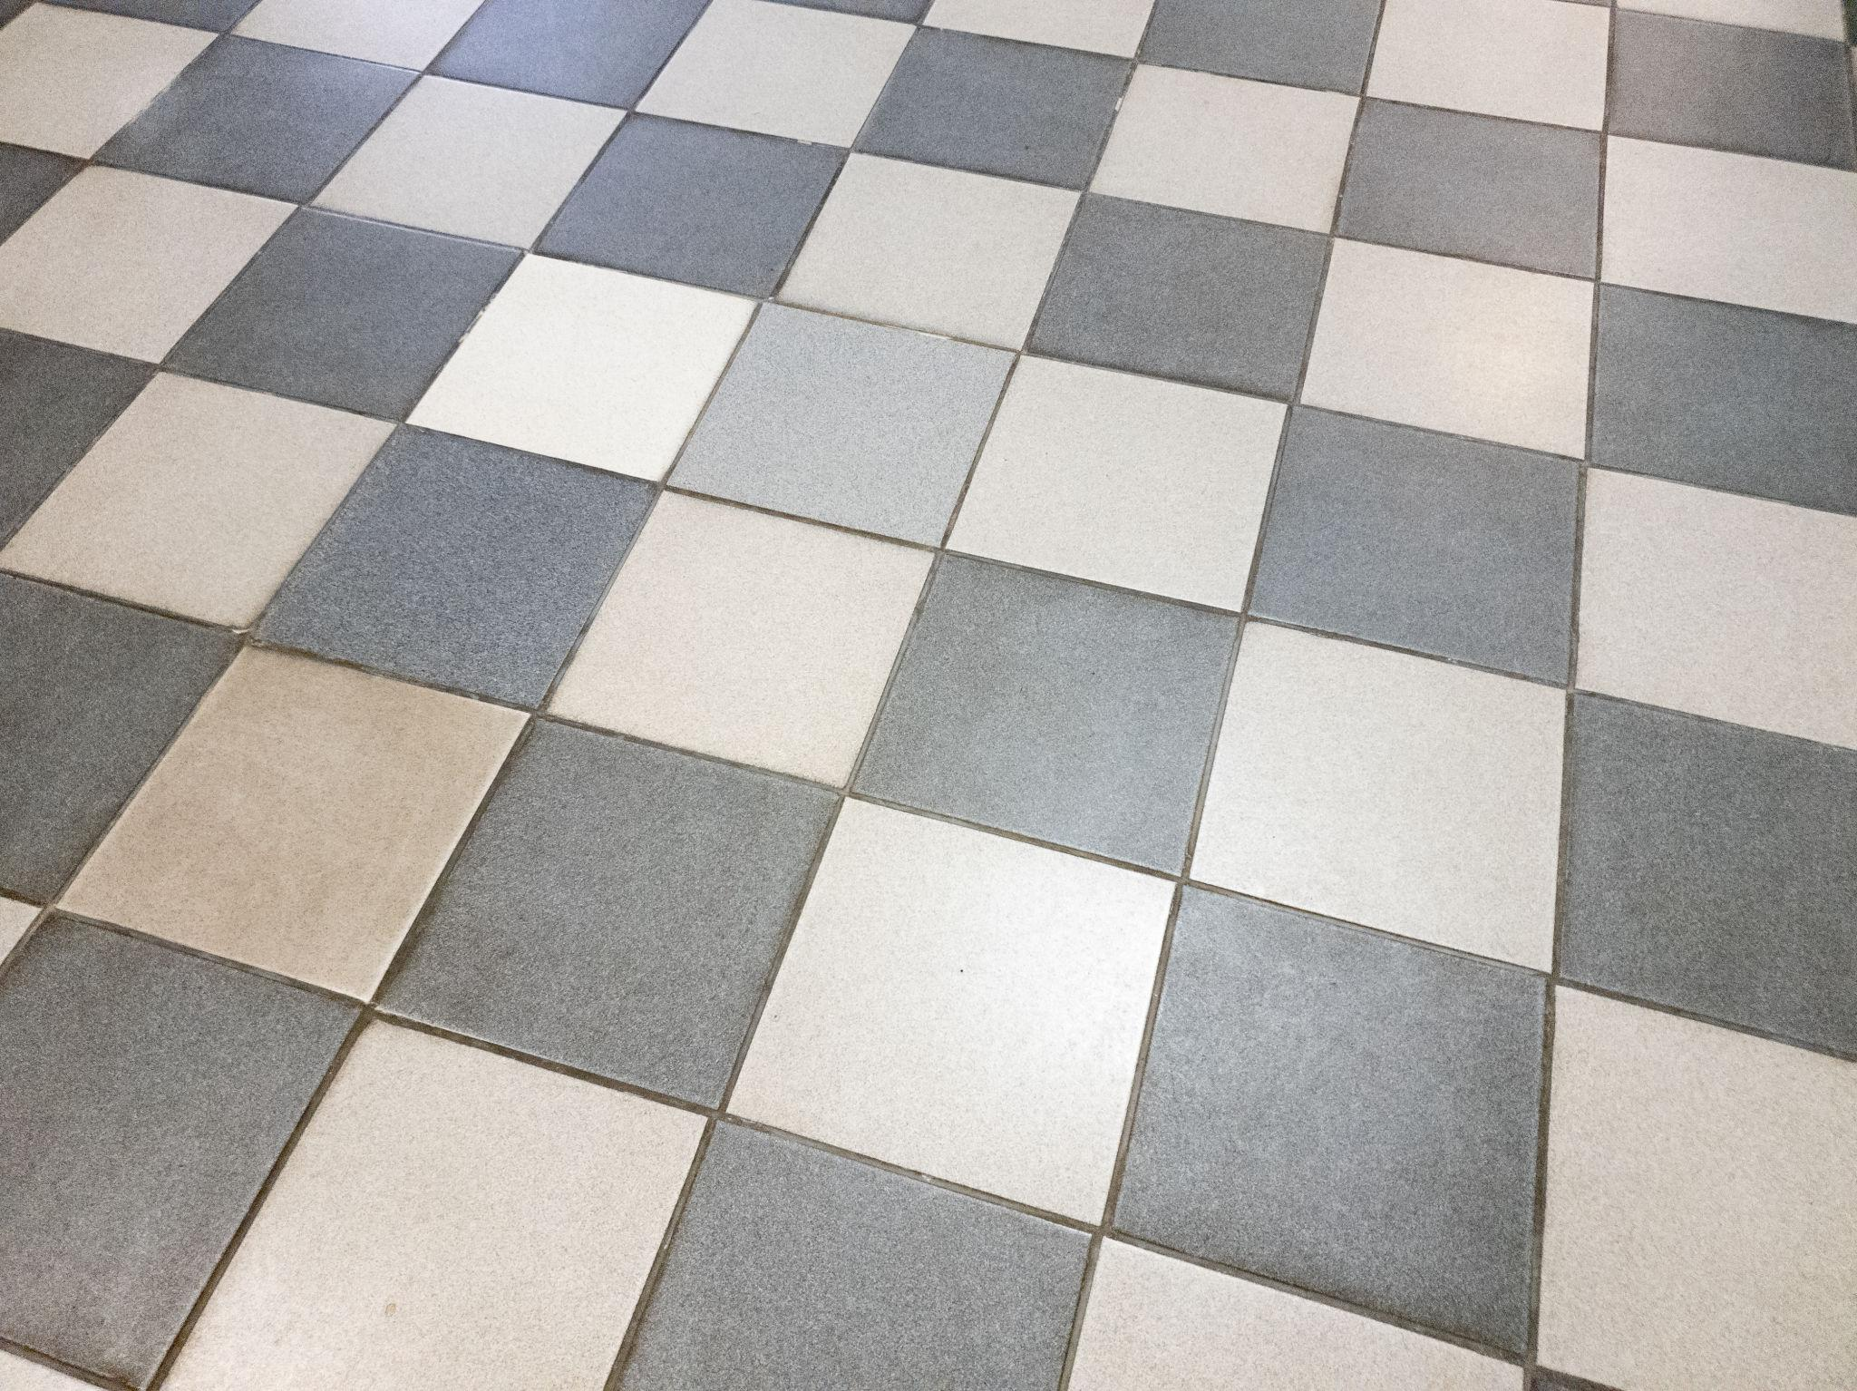
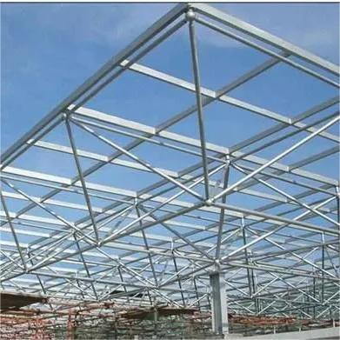


Advantages
# Source: AI Source: Provided by: [Data Path: Persons Table -> ID Column: 1, Name_En Column: Motasem Essam] -> From: [ChatGPT] on [7/25/2026]
- Simple to analyze using four sides and four angles.
- Many useful formulas exist for special quadrilaterals.
- Important for understanding polygons and plane geometry.
- Widely used in architecture, construction, engineering, and design.
- Provides a foundation for studying parallelograms, rectangles, rhombi, squares, trapezoids, and kites.

Limitations
# Source: AI Source: Provided by: [Data Path: Persons Table -> ID Column: 1, Name_En Column: Motasem Essam] -> From: [ChatGPT] on [7/25/2026]
- A general quadrilateral does not have one simple area formula based only on its four side lengths.
- Different types of quadrilaterals have different properties.
- A diagram alone should not be used to assume that sides or angles are equal.
- Concave quadrilaterals require additional care when analyzing angles and diagonals.

Key Points
# Source: AI Source: Provided by: [Data Path: Persons Table -> ID Column: 1, Name_En Column: Motasem Essam] -> From: [ChatGPT] on [7/25/2026]
- A quadrilateral is a polygon with exactly four sides.
- It has four vertices and four interior angles.
- Every quadrilateral has exactly two diagonals.
- The interior-angle sum is:
$$\boxed{{360}^{∘}}$$
- Its perimeter is:
$$\boxed{P=AB+BC+CD+DA}$$
- Major types include:
  - Parallelogram
  - Rectangle
  - Rhombus
  - Square
  - Trapezoid
  - Kite
- A square is both a rectangle and a rhombus.
- Quadrilaterals can be convex or concave.

Conclusion
# Source: AI Source: Provided by: [Data Path: Persons Table -> ID Column: 1, Name_En Column: Motasem Essam] -> From: [ChatGPT] on [7/25/2026]
A quadrilateral is a four-sided polygon and one of the fundamental classes of figures in plane geometry. Its sides, vertices, angles, diagonals, perimeter, and area provide the basis for understanding specialized quadrilaterals such as parallelograms, rectangles, rhombi, squares, trapezoids, and kites.

